Title of the contribution

M. Rossi^{1,2}, ...

¹ Affiliation1..., Address, Country
² Affiliation2..., Address, Country

Abstract

- Abstract maximum length: 2 pages
The Abstract is intended as a short contribution by itself. All the abstracts will be collected in a Book of Abstracts.
- The Abstract can contain figures as indicated below
- Please submit the Abstract as a pdf file

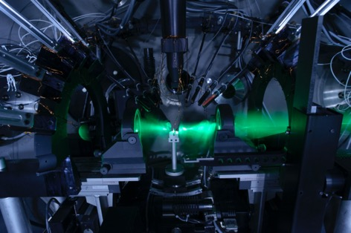
Figure 1. The caption of the figure.

References
1. First reference
2. Second reference

Acknowledgements
The acknowledgements.

