Prototype of a remote LIBS system for the chemical characterization of tungsten-based PFCs

S. Almaviva¹*, D. Dongiovanni¹
1 ENEA, Italian National Agency for New Technologies, Energy and Sustainable Economic Development, Frascati Research Center, Via Enrico Fermi, 45, I-00040 Italy
*Corresponding author: salvatore.almaviva@enea.it

New nuclear fusion devices under construction, such as ITER, and under design, such as DEMO, are foreseen to have long intervals between shutdowns, to increase the machine's duty cycle.
However, it will be necessary to periodically monitor the machine's plasma-facing components (PFCs) getting information on the areas of erosion, redeposition and mixing of the eroded materials with the unburned fusion fuel. Laser-Induced Breakdown Spectroscopy (LIBS) can accomplish this task as it can chemically characterize PFCs without any preliminary manipulation, in real time and in situ, by operating outside the vacuum vessel without breaking the vacuum.
In this paper we present a prototype of a remote LIBS setup, which focuses the laser at a distance of 4.4 m from the tungsten target and collects the signal of the LIBS plasma from a distance of about 6.6 m, as depitched schematically in figure 1 (top) and shown in figure 1 (bottom).
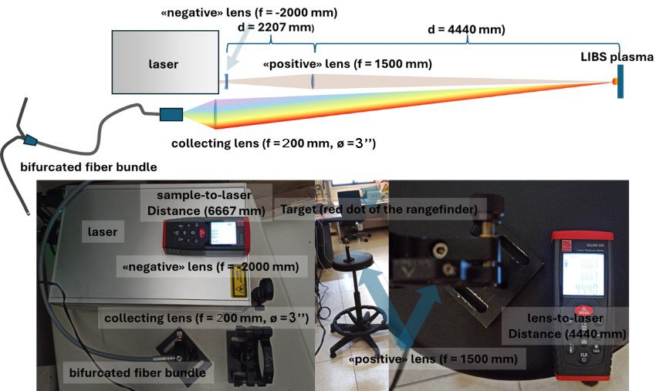
Figure 1 (top) sketch of the remote LIBS system simulating sampling and collection of the signal at distances of meters from the laser and the collection optics
The results obtained on tungsten targets allowed us to clearly reveal the spectral emissions of tungsten and environmental hydrogen, considered here as a proxy for the unburned D-T fuel, with a good S/N ratio even at a single laser shot.

