Development of a dual vertical Thomson scattering diagnostic system on EAST

Y. Li^{1,2}, Q. Zang^{1,*}, M.F. Ren¹, Y.X. Zhu^{1,2}, J.W. Liu¹, L. Chen¹, G.L. Lin^{1,2}, J.C. Wang^{1,2}, Y.L. Tang¹
¹ Institute of Plasma Physics, Hefei Institutes of Physical Science, Chinese Academy of Sciences, Hefei 230031, China
² University of Science and Technology of China, Hefei 230026, China
*Author to whom any correspondence should be addressed. E-mail: zangq@ipp.ac.cn
e-mail (speaker): yan.li@ipp.ac.cn
e-mail (corresponding): zangq@ipp.ac.cn

Abstract
A dual diagnostic system that combines traditional Thomson scattering (TS) system with Television Thomson Scattering (TVTS) system based on laser beam combining technique is developed and experimentally demonstrated on EAST. The vertical dual TS system constructed in this study primarily consists of five components: the laser light source system, optical transmission system, optical collection system, spectrometer and detection system, and synchronous trigger timing control system. The system schematic is shown in Figure 1. In tokamak plasma, Thomson scattering electron temperature measurements are affected when the electron velocity distribution function deviates from the Maxwellian distribution. To investigate and evaluate this phenomenon, a dual Thomson scattering diagnostic system is required to overcome the limitations of a single system. The TVTS system in the dual system primarily covers a 32 mm region along the Z-axis with a spatial resolution of approximately 10 mm.
The study analyzed the theoretical basis for collaborative measurements in dual TS system and conducted subsystem optimization designs to meet the requirements for synchronous operation of dual systems. Based on the design of the two systems, the dual system can perform a comparative analysis of the Thomson scattering signals across T_{e} from 50 to 4000 eV and n_{e} from 0.1 to $\text{1×}{\text{10}}^{\text{19}}{\text{m}}^{\text{-3}}$. Experiments on EAST H-mode discharges demonstrate the feasibility of the laser beam combining technique and the reliability of the dual diagnostic system. Subsequent simulation analysis and collaborative diagnostic methods for the dual systems are further discussed, offering new insights into electron temperature measurement in non-Maxwellian plasma. This work is significant for optimizing EAST plasma confinement performance, investigating core transport barriers, and advancing research on plasma dynamics.
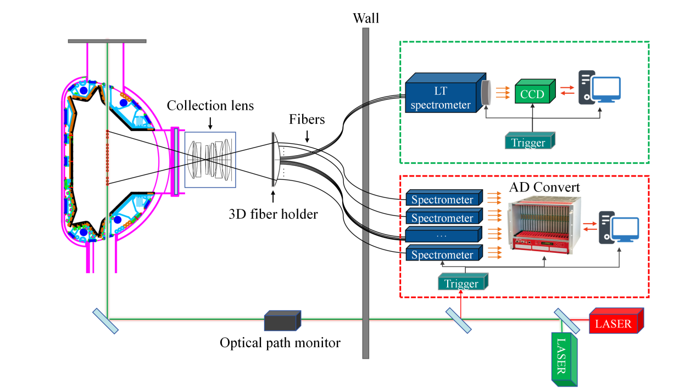
Figure 1. Schematic diagram of the dual system for traditional TS and TVTS system in EAST.

Keywords: TV Thomson scattering; Tokamaks; Thomson Scattering; Beam combining; Non-Maxwellian distribution;

