Recent Progress in Intelligent Processing of Multimodal Diagnostic Data from the EAST Tokamak

T. Lan¹, L. F. Yang¹, J. S. Zhang², X. P. Xie², A. D. Pan¹, J. L. Xie², W. X. Ding², Y. X. Jie¹, H. Q. Liu¹, Y. T. Song¹, and EAST Team.

¹Institute of Plasma Physics, Chinese Academy of Sciences, Hefei, Anhui 230031, China
²School of Nuclear Science and Technology, University of Science and Technology of China, Hefei, Anhui 230026, China

EAST tokamak, one of the most important Magnetic Confinement Fusion (MCF) devices in China, provides an important experimental platform for the study of steady-state advanced plasma operation. Over sixty diagnostic systems on EAST tokamak provides huge amounts of multimodal diagnostic data about MCF plasma. Diagnostic data of EAST tokamak has the characteristics of volume, variety and velocity. In many cases, intelligent fusion data processing methods based on machine learning have advantages over traditional methods. This report reviews some recent progresses on intelligent processing of multimodal diagnostic data on EAST tokamak, including data cleaning, profile reconstruction, and spectral decomposition. To guarantee the availability and reliability of data source in MCF devices, Time-Domain Global Similarity (TDGS) method based on machine learning technologies is developed for automatic data cleaning. The performance of TDGS method on EAST POlarimeter–INTerferometer (POINT) system has reached 0.9871 ± 0.0385. Convolutional Neural Networks (CNN) and Back Propagation Neural Network (BPNN) are introduced into reconstructing electron density profiles from line-integrated density measurements of interferometers in EAST tokamak. The established CNN model can predict the probability distribution of density profiles accurately, fast, and robustly to noise and interference. Compared to the traditional Park-matrix method, the BPNN-based model demonstrates significantly faster performance and greater robustness against system noise, making it suitable for real-time control of density profiles. Moreover, an improved genetic algorithm is applied to decompose the scattering spectra of Collective Thomson scattering (CTS). This improved genetic algorithm with a new fitness function can obtain a more precise ion temperature from scattering spectra of CTS and does not rely on the measurement of other diagnostic systems, which has an extensive application prospect in data processing of CTS. Machine learning has played an important role in fusion data science, contributing to safe operation and physics discovery, and will play a more and more important role in the future fusion reactors.

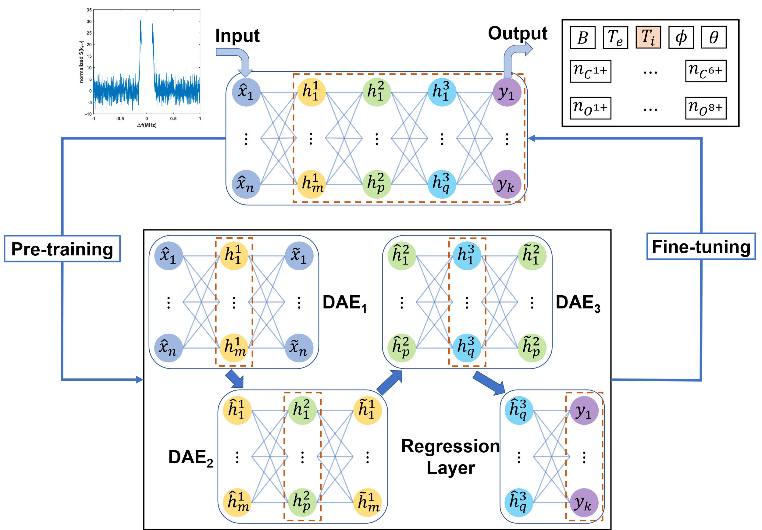
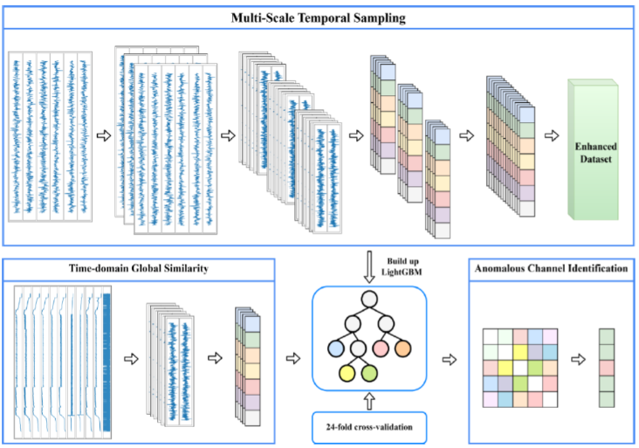
(b)
(a)

Figure 1: (a) The Real-Time Time-domain Global Similarity (RT-TDGS) method structure diagram. (b) Principal structure and training stages of Stacked Denoising Autoencoder (SDAE).

References
[1] T J Wang*, R Q Zhang, L Qian, Y T Song, T Lan*, H Q Liu*, and K Li*. Validating a Koopman-Quantum Hybrid Paradigm for Diagnostic Denoising of Fusion Devices. SCIENCE CHINA Physics, Mechanics & Astronomy 2026.
[2] L F Yang, T Lan*, S X Wang, Yao Zhang, H Q Liu and Y X Jie*. Real-time data cleaning method for multi-channel diagnostic systems based on machine learning on EAST tokamak. Plasma Physics and Controlled Fusion, 2026, 68(1): 015033.
[3] Xie XP, Lan T*, Liu HQ, Zhu X, Ding WX*. Robust electron density profile inversion based on neural networks for interferometer system on EAST tokamak. Plasma Physics and Controlled Fusion, 2025, 67(4): 045001.
[4] Zhang JS, Lan T*, Zeng QB, Wu ZW, Zhuang G, Xie JL*. Spectral decomposition for collective Thomson scattering based on an improved genetic algorithm[J]. Review of Scientific Instruments, 2024, 95(9).
[5] Lan T, Liu H Q*, Ren Q L*, Zhu X, Mao W Z, Yuan Y, Wang YF. Electron density profile reconstruction with convolutional neural networks[J]. Plasma Physics and Controlled Fusion, 2022, 64(12): 124003.

