Particle-in-Cell model of nanosecond point-to-plane high-pressure discharge

F. Taccogna¹, P. Minelli¹, D. Bruno¹, and F. Cichocki²,
¹ Institute for Plasma Science and Technology – CNR via Amendola 122/D 70125 Bari - Italy
² Nuclear Department (NUC), ENEA, C.R. Frascati, via Fermi 45, 00044 Frascati, Italy

In the frame of non-equilibrium discharge processing for CO₂ valorization and nitrogen fixation, nanosecond repetitively pulsed (NRP) discharges have shown a promising set of performances [1]. A modelling attempt must address microscopic time/space-resolved description of the physics and kinetics of the discharge. To this end, Particle-in-Cell (PIC) models seem to be the only option. The point-to-plane discharge simulated is made of a tungsten needle and an SS plate with inter-electrode gap of 3 mm. The voltage and current plot at 100 Torr N₂ gas is shown in Fig. 1.

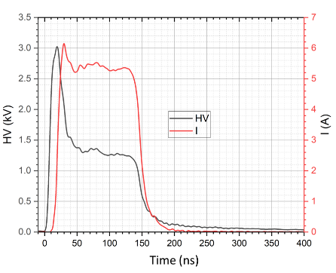
Fig. 1 Applied voltage and current at 100 Torr.

Simulations are run with the PICCOLO code, described in more detail in [2,3], and feature a Particle-in-Cell / Monte Carlo Collision (PIC-MCC) model in 2D(r,z)-cylindrical axi-symmetric coordinates to capture the nitrogen plasma (electron / N⁺ and N₂⁺ ions) dynamics of the single n^{th} pulse. A prescribed voltage is imposed at the anodic needle, while the plate is kept grounded. The simulation starts by seeding a fixed number of electrons / ions with a given non-uniform spatial distribution (initial plasma density n₀ = 10¹⁷ m⁻³) mimicking the residual charges (globally neutral) that are present in the system after the previous (n-1)^{th} pulse in the experiment. The neutral background density of N atoms, of all the vibrational levels of the ground N₂(X¹Σ_{g}⁺,ν=0-59) and of the metastables N₂(A³Σ_{u}⁺) and N₂(a′¹Σ_{u}⁻) is continuously updated by self-consistently solving their master equations knowing the electron-induced source/sink frequency term ν_{eX}=<σ_{eX}v_{e}n_{e}>. The radiative cascade from the excited triplets states B, W, B’, C and from the quintet states A’, C’’ to the triplet metastable state A is too slow compared to the pulse duration (200 ns) to give a contribution to populate the triplet state A. More than 30 electron-induced collisions with neutrals, Coulomb collisions and ion-neutral momentum and charge exchange collisions are included.

It is shown that a diffuse discharge develops with a structure similar to a that of a glow discharge, with negative glow and Faraday dark space, highlighting the importance of non-local contributions to the electron energy distribution function (EEDF) as shown in Fig. 2. Like in a DC glow discharge, the cathodic potential drop (more than 600 V) in front of the grounded plate accelerates ions which induce secondary electrons emission from the cathode. This in turn allows the ionization feeding the ion production and the further electron emission after ion impact on the plate.
a)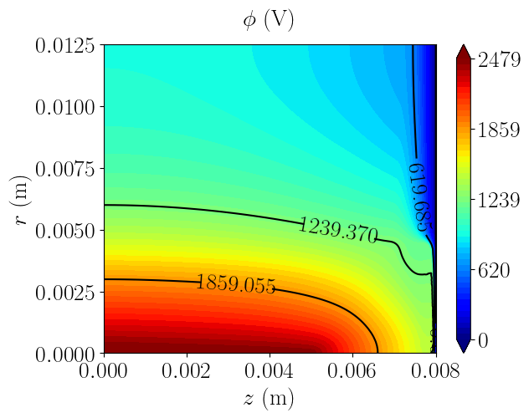b)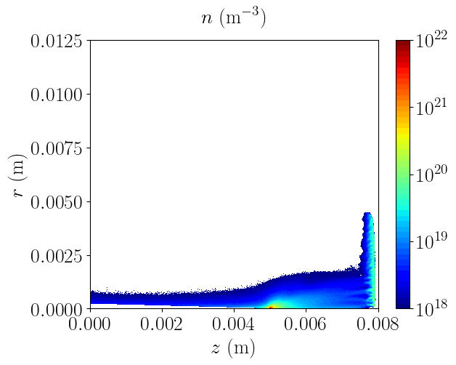c)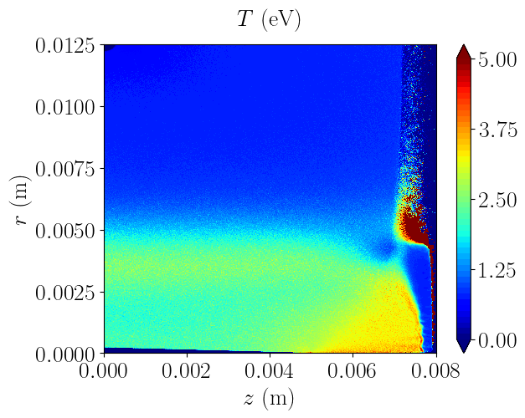
Fig. 2 2D(r,z) plasma parameters (a) plasma potential, b) electron density and c) electron temperature) maps after 27 ns from the beginning of the pulse.

Acknowledgement
Work funded by the European Union under the National Recovery and Resilience Plan (NRRP) – Next Generation EU, projects PRIN 2022 PLASMODD Prot. 2022J5NBBN.

References
[1] C. Montesano, T.P.W. Salden, L.M. Martini, G. Dilecce, P. Tosi, “CO₂ Reduction by Nanosecond-Plasma Discharges: Revealing the Dissociation’s Time Scale and the Importance of Pulse Sequence” J. Phys. Chem. C, 127, 10045-10050 (2023).
[2] F. Cichocki, V. Sciortino, P. Minelli, F. Taccogna, “PIC modeling challenges in diverse low temperature plasma scenarios”, ESCAMPIG XXVI, Brno, Czech Republic, July 9–13, 2024.
[3] F. Taccogna, P. Minelli, F. Cichocki, “PICCOLO: a Particle-in-Cell code suite for low-temperature plasmas”, XXXVI International Conference on Phenomena in Ionized Gases (ICPIG), Aix-en-Provence, France, July 20-25, 2025.

